Your title which could extend over two lines as shown
in this example, in bold, 14pt Times New Roman centred

J. F. Smith^{1,2}, J. Pérez¹, P. Martin²
¹ First address
² Second address

Please use the style of this document. The title of the abstract should be written in Times New Roman, bold, 14pt, centered. Only the initial letter should be capiatlised. The name of the presenting author (not necessarily the first author) is underlined. The author list and affiliation(s) are centred, as shown above. There should be one blank line between the title and the authors’ names and their affiliation, and one blank lines between the affiliation(s) and the beginning of the body text without any punctuation marks at the end of these lines.
Your abstract must be written in English. Maximum 1 A4 page written in Times New Roman 11pt with “justified” alignment mode. Keep “default” margins: top, bottom, left, right: 2.54 cm. You can include Figures, equations, tables or references, but the total text must not exceed the limit of one page, including figure(s) and references. References should be cited by number enclosed in square brackets [1]. References should be in 10pt Times New Roman with formatting as shown: Initial(s) followed by name, Journal name in Times New Roman italic, Journal volume in Times New Roman bold, year in parenthesis, and pages, all Authors’ names up to three, or else First Author et al. Please, do not use “cite” or “BibTeX”. The same is valid for Figures, Tables or Equations, please do not use “ref” or “label”, use absolute references. Do not insert text or references in “footnote” mode or other encoding. Do not modify the footer or the header.
The proper way to include an equation is shown below [2]
2 CO + O₂ (⎯→) 2 CO₂ (1)
Figures should be included as shown, centered and within the text [3, 4]. Figure captions should be in 10pt Times New Roman.
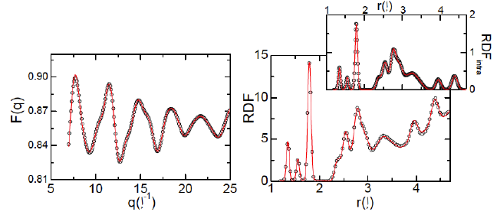
Figure 1: The caption of your figure, centred.

[1] A. One, A. Two, A. Three, Physica B 10 (1995), 999.
[2] PROGRAM is available on http://your.server.edu/software/myprogram.
[3] J. F. Smith et al., Phys. Rev. B 81 (2012), 00000.
[4] S. Johnson, J. Smith in The Book Title, A. Einstein (Ed.), Editorial, Oxford (2012), 999.

Corresponding author: j.f.smith@youruniversity.edu

