Your title that could extend on two lines as shown
in this example: Bold, Times 14, Centred

J. F. Smith^{1,2}, J. Pérez¹, P. Martin²
¹ First address
² Second address

Authors: the name of the presenting author (not necessarily the first author) is underlined, centred, as above, and so the affiliation(s). There should be one blank line between the title, the authors’ names and their affiliation and one blank lines between the affiliation and the beginning of the body text without any punctuation marks at the end of these lines.
Your abstract must be written in English. Maximum 1 page A4 written in Times 11 alignment in mode “justify”. Keep “Normal” margins: top, bottom, left, right: 2.54 cm. You can include Figures, equations, tables or references, but not exceeding the limit of 1 page, You can cite references writing directly the number reference like this [1]. Please, do not use “cite” or “thebibliography”. The same is valid for Figures, Tables or Equations, please do not use “ref” or “label”, use absolute references. Do not insert text or references in “footnote” mode or other encoding.
For multi-component systems, it is not possible, in a single diffraction experiment, to unravel the individual partial pair distributions [2] to obtain, for example, direct information about the chemical ordering in the material.
2 CO + O₂ (⎯→) 2 CO₂ (1)
The structural and microstructural characterisation of nanomaterials and defective crystalline solids is of fundamental importance for understanding their physical and chemical properties [3, 4].
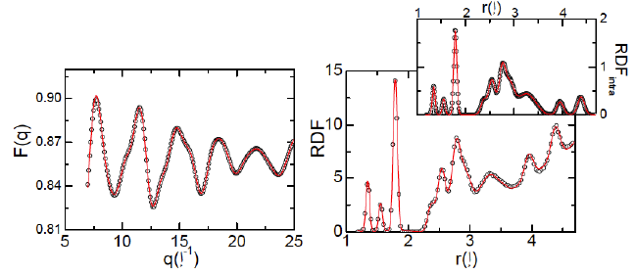
Figure 1: The caption of your figure, centred.

[1] A. One, A. Two, A. Three, Physica B 10, 999 (1995)
[2] PROGRAM is available on http://your.server.edu/software/myprogram
[3] J. F. Smith et al., Phys. Rev. B 81, 00000 (2012)
[4] S. Johnson, J. Smith in The Book Title, A. Einstein (Ed.), Editorial, Oxford (2012), p. 999

Contact: j.f.smith@youruniversity.edu

