Cold Neutron Guide Test Station with Polarization Analysis at HANARO

K.-Y. KIM¹, S.-M. LEE², S.-W. KIM¹, C.-S. KIM¹, J.-H. HAN¹, J.-Y.KIM, J. H. LEE¹, S.-J. CHO¹

¹ Neutron Science Division, Korea Atomic Energy Research Institute, Daejeon 34057, South Korea
²Laser Application Research Team, Korea Atomic Energy Research Institute, Daejeon 34057, South Korea

Guide-test station (G-TS, Fig.1) instrument at CG1 beamline in cold neutron guide hall at HANARO has been dedicated to test the unpolarized neutron supermirrors produced in-house. In order to make it feasible to measure polarizing supermirrors and magnetic thin films, we adopted polarizing neutron optics such as polarizer, neutron spin flippers, spin analyzer, guide field. HOPG (002) monochromator, made of seven pieces of slabs (40mm×20mm×2mm), deflects out neutrons with wavelength of 4.34 Å by a take-off angle of 80° from neutron guide with a cross-section of 20 mm wide×150 mm high. Monochromatic neutron wavelength is confirmed via time-of-flight technique and neutron flux was measured via gold foil activation analysis to be 1.12E6 n/sec/cm² at sample position at the condition of vertically focusing monochromator and wide open slit condition. Double reflection polarizer/wavelength filter device, switchable between polarized and unpolarized beam channels 2mm wide, was produced by Dr. Thomas Krist, Nano Optics Berlin GmbH, Germany.

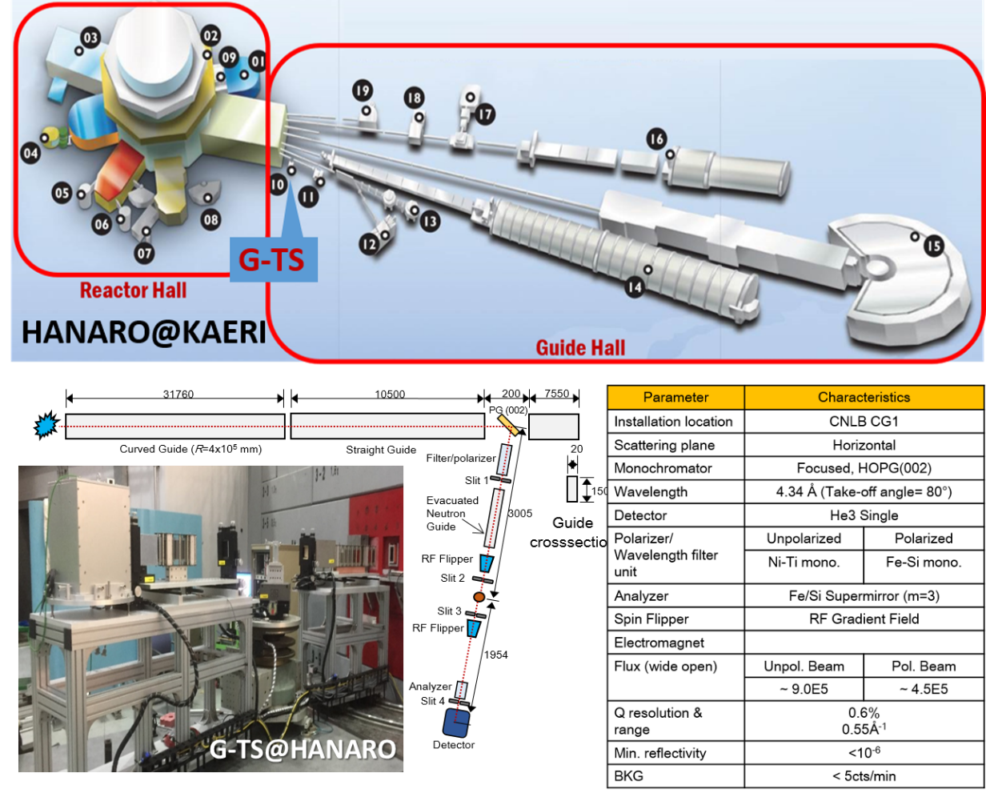
Figure 1. (Top) HANARO neutron scattering facility, (b) G-TS instrument and specifications

Compared to He-3 polarizer or Heusler crystals, neutron beam with high polarization as well as high transmission can be available. Spin-up neutrons are produced from double reflection polarizer when neutron beam is incident on mirrors within angular bandpass of 0.2 degree around an incidence angle of 1 degree. In addition, this solid state device is maintenance-free in that it filters out second harmonic neutrons and makes widely used N₂-cooled Be filter unnecessary. Lastly, background noise is low because it is located right after monochromater inside heavy concrete shielding blocks and most of unwanted neutrons are unable to come out of the beam shutter. Spin analyzer is made of a single blade of m=3 Fe/Si supermirrors coated on both side of Si wafer. This analyzer was also fabricated by NOB GmbH. Spin down neutron is transmitted while, spin-up neutrons are totally reflected if incidence angle is in between their critical angles. To flip the neutron spin polarization by 180°, radio frequency gradient field spin flippers (SF) were in-house fabricated. Two SFs are located upstream and downstream with respect to sample position. Ac current via RCL series resonating circuit is applied to rf coil, producing horizontal ac field. Vertical dc magnetic field strength could be adjustable by a hybrid architecture combining iron plate and dc electromagnet. Neutron spin can be flipped by 180° when Larmor frequency associated with precession motion around dc vertical field is set to be equal to the ac resonating frequency near the center of rf-coil. It turns out that 1st SF has 115. 5kHz, Vpp=3.5 V, dc field =3.9mT, dc current= 3.5A and 2nd SF has 140.0kHz, Vpp=3.5 V, dc field =4.8mT, dc current= 3.0A, respectively. Finally, polarized neutron beam with overall spin flipping ratio (~ 90) and polarization (~97%) using a combination of polarizer and spin flipper and spin analyzer can be available at the G-TS instrument.

E-mail of the corresponding author: kykim3060@kaeri.re.kr

