Development of a Liquid Neutron Reflectometer at China Spallation Neutron Source
Guang Wang^{a,b*}, Junrong Zhang^{a,b} & Tianjiao Liang^{a,b*}
ª Spallation Neutron Source Science Centre, 523803, Dongguan, China;
^{b} Institute of High Energy Physics, Chinese Academy of Sciences, 100049, Beijing, China
E-mail: wangguang@ihep.ac.cn & tjliang@ihep.ac.cn
Interfaces are scientifically crucial as they allow symmetry breaking, leading to many novel and interesting phenomena. This is not only true for metal magnetic systems but also for biological interfaces which are crucial for life and consist of stacked layers of proteins, and catalysts whose surfaces are also critical to how they function. Compared to those techniques either lack chemical sensitivity to the sample composition or require invasive labelling, neutron reflectivity is unique in its ability to probe these buried interfaces and surfaces, particularly to derive composition and structure information in response to external stimuli. A complementary reflectometer (the reflectometer with a vertical sample geometry has commissioned) with a horizontal sample geometry that will cover the largest and fastest growing scientific areas, including soft matter, advanced materials and life sciences, has been scheduled in Phase Ⅱ of China Spallation Neutron Source (Figure 1). The core scientific areas potential to be addressed include, but not limited to:
- Self-assembly systems of surfactants, polymers and proteins at solid-liquid and liquid-liquid interfaces;
- Polymer science in thin films, e.g., inter-layer movement, annealing/drying/exchange/wetting processes;
- Interfacial kinetics in e.g., plastics, polymer blends, drug delivery and implant materials, chemical and biological sensors;
- Advanced materials that undergo structural changes in response to external stimuli (chemical, mechanical, electrical or magnetic) for various applications;
- Atmospheric science that involves aerosol formation and changes at air-water interface in response to climate change;
- Surface chemistry involves changes in structure or chemical composition, e.g., catalysis, oxidation, corrosion or other surface reactions, receptor-ligand binding, drug-target interactions, surface functionalization etc.;
- Bioscience regarding almost everything that can attach to or penetrate into cell membranes.
Keywords: China spallation neutron source; Liquid neutron reflectometer; Scientific areas
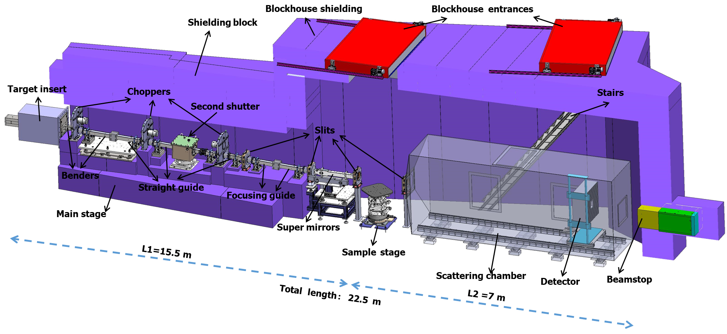
Figure 1. Instrument layout of the reflectometer

