Polymer-surfactant (P-S) complexes have been a subject of extensive research efforts, due to their high industrial and scientific relevance both in solution [1] and on the interfaces [2]. A feature of polymer-surfactant complexes is that they are able to assemble into the supramolecular complexes above a certain critical association concentration (cac). However, our understanding of the intermolecular interactions underpinning the mechanism and pathway of the complex formation remains incomplete, especially in the case of structures formed in planar confinement.

In this work, in order to gain mechanistic insights, we have studied the interactions between a flexible polyelectrolyte and surfactants (amphoteric and anionic) in a weak interaction regime, where the driving force of the interaction is the van der Waals forces. Surface confined mesophase of these complexes were investigated using X-ray and neutron reflectivity, combined with grazing incidence diffraction. We have found spontaneously formed highly porous multilayer structures (Figure 1, A), facilitated by the presence of the polymer, contrary to the rupture of multilayer vesicles, observed earlier [3]. Formed films are responsive to humidity, which promoted reorganization of the multilayer and melting of the surfactant crystal, formed in the spin-coating process, in favour of formation of the liquid-crystal-like structure with correlated roughness, as indicated by the diffuse scattering (Figure 1, B)

Our results show spontaneous formation of structured film during both spin- and dip-coating of the complexes. We have established that surfactants are uniformly distributed in the polymer film and reorganize upon exposure to humidity and investigated the influence of complex formation in solution. Finally, we have compared the structure of surface confined mesophase with the precipitates formed when the electrostatic attraction dominates.

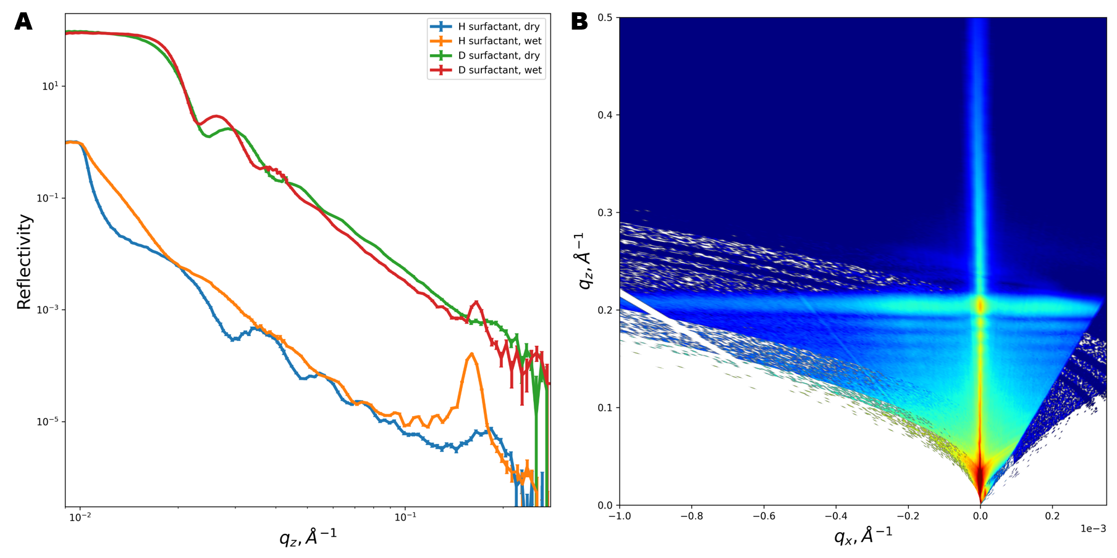

Figure 1. A. Neutron reflectivity profiles for hydrogenated and deuterated surfactant contrast, measured at 0% humidity (dry) and 80% humidity (wet). B. Reciprocal space map obtained during X-ray reflectivity measurement of the same composition sample at 60% humidity. Note the presence of periodic diffuse scattering stretched along qx direction, indicating roughness correlations in the multilayer.

[1] C. D. Bain, et al., Complexes of surfactants with oppositely charged polymers at surfaces and in bulk. Adv.Col.Int.Sci, 155(1):32–49, 2010.  
[2] L. Fernandez-Pena, et al., Impact of the bulk aggregation on the adsorption of oppositely charged polyelectrolyte-surfactant mixtures onto solid surfaces. Adv.Col.Int.Sci, 282:102203, 2020

*[3] Micciulla, S. et al. One-step procedure for the preparation of functional polysaccharide/fatty acid multilayered coatings. Commun Chem 2, 61 (2019).*